**Scenario 1**

As a user I want to be able register to the system, so that I can view information about online courses.

**Acceptance Criteria**

The following fields should be available on the Registration screen:

**Name** – field up to 25 characters, should accept only letters

**Email** -  format - xxx@domain, system should display following validation message -  ‘Please use valid email format.’ in case of invalid format. It should be unique entry.

**Username**  - alphanumeric field up to 50 characters, should be unique entry, if entered duplicate username, system should display message – ‘Username already exists.’

**Password** -  8-14 alphanumeric characters

**Confirm Password** – the value should be the same as password

**Submit button** – After submit user should see following message “Your account has been successfully created.”

***Note***: In case of invalid data no need to mention in red fields

**Bug 1-Wrong Register page “Name” field**

**Environment/URL:** [**QWALLITY Workspace (qwallity-prod.onrender.com)**](https://qwallity-prod.onrender.com/login)

**Operation System:** Windows 11 Home 64-bit

**Version**: 1

**Browser:** Microsoft Edge

**Submit Date:** 4/21/2023

**Reporter:** Armine Melkonyan

**Steps to Reproduce:**

1. Enter Qwallity App
2. Click “Register” Button
3. Fill in all fields (in “Name” field write numbers and symbols)
4. Click “Sumbit“ Button

**Expected Result: “**Name**“** fieldshould accept only letters

**Actual Result: “**Name**“** field accept numbers and symbols

**Screenshot/video:** Screenshot is attached

**Severity:** Medium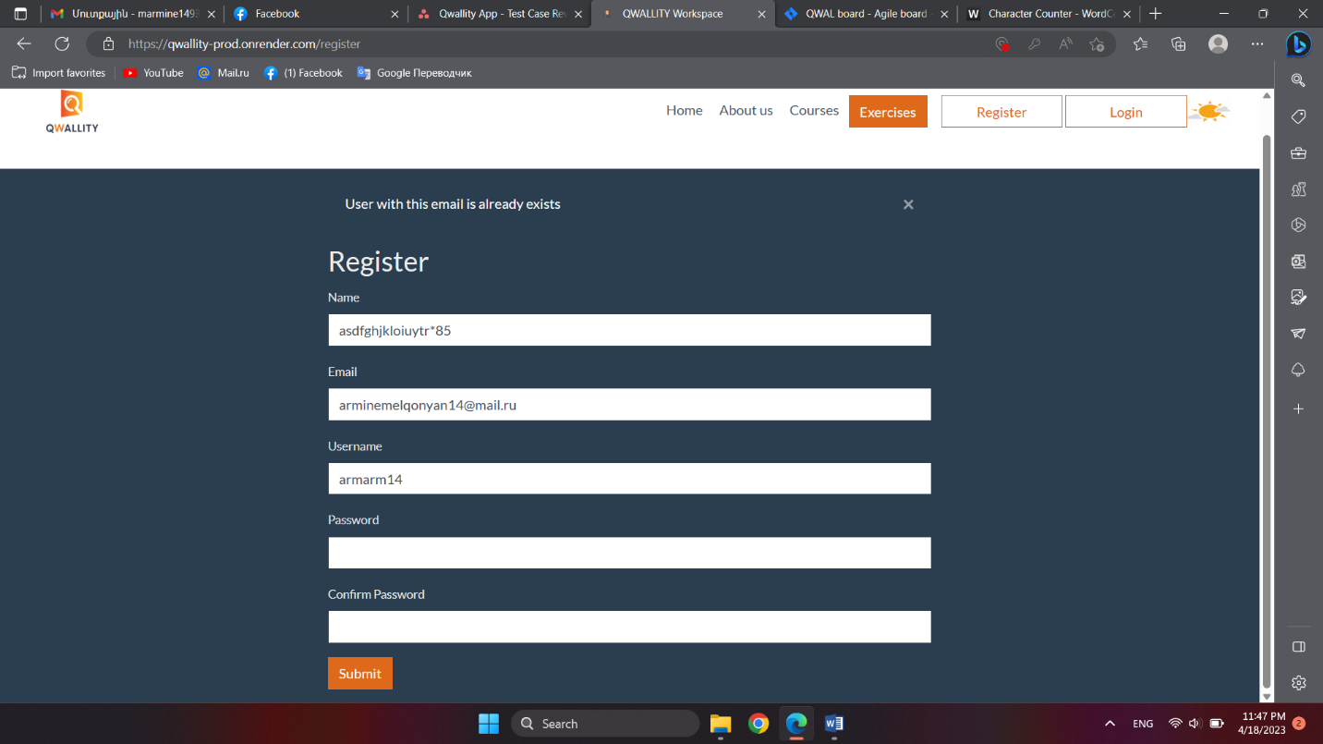

**Bug 2-Wrong Register page “Email” field validation**

**Environment/URL:** [**QWALLITY Workspace (qwallity-prod.onrender.com)**](https://qwallity-prod.onrender.com/login)

**Operation System:** Windows 11 Home 64-bit

**Version**: 1

**Browser:** Microsoft Edge

**Submit Date:** 4/21/2023

**Reporter:** Armine Melkonyan

**Steps to Reproduce:**

1. Enter Qwallity App
2. Click “Register” Button
3. Fill in all fields (in “Email” field write incorrect format email)
4. Click “Sumbit“ Button

**Expected Result:** System should display following validation message - “Please use valid email format”

**Actual Result:** System shows this validation message- “Email format is not valid”

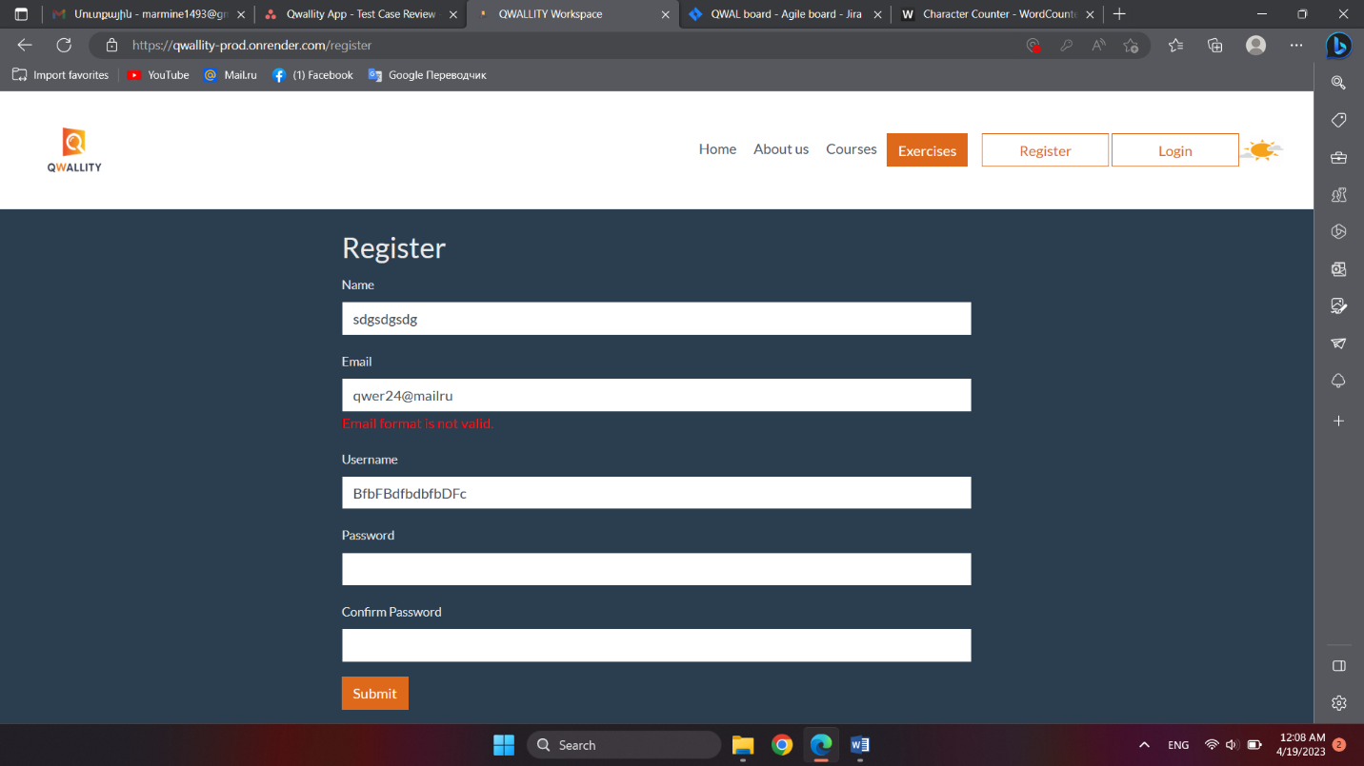**Screenshot/video:** Screenshot is attached

**Severity**: Low

**Bug 3-Internal Server error Register incorrect “Username” field**

**Environment/URL:** [**QWALLITY Workspace (qwallity-prod.onrender.com)**](https://qwallity-prod.onrender.com/login)

**Operation System:** Windows 11 Home 64-bit

**Version**: 1

**Browser:** Microsoft Edge

**Submit Date:** 4/21/2023

**Reporter:** Armine Melkonyan

**Steps to Reproduce:**

Enter Qwallity App

Click “Register” Button

Fill in all fields (in “Username” field 50 characters)

Click “Sumbit“ Button

**Expected Result:** System will be accept data

**Actual Result:** Systemshows Internal server error page

**Screenshot/video:** Screenshots is attached

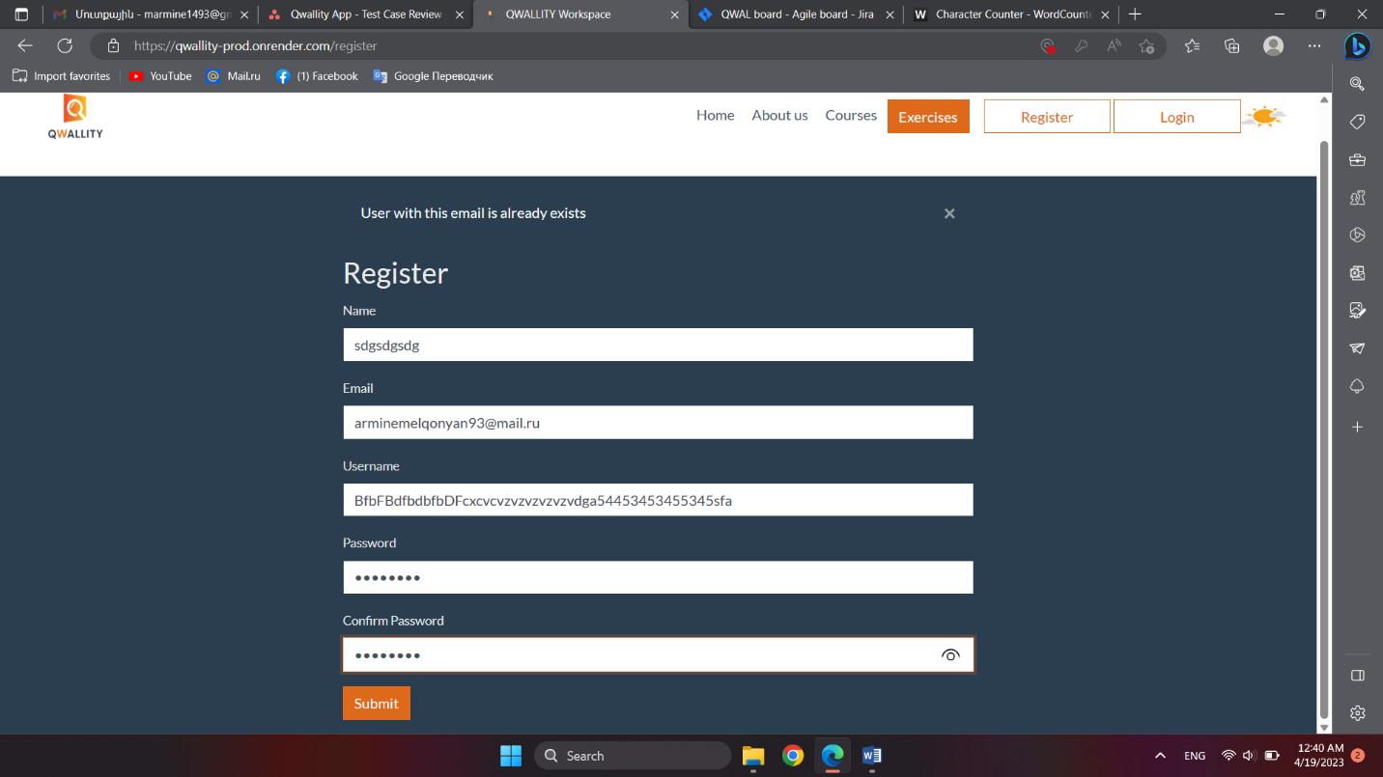

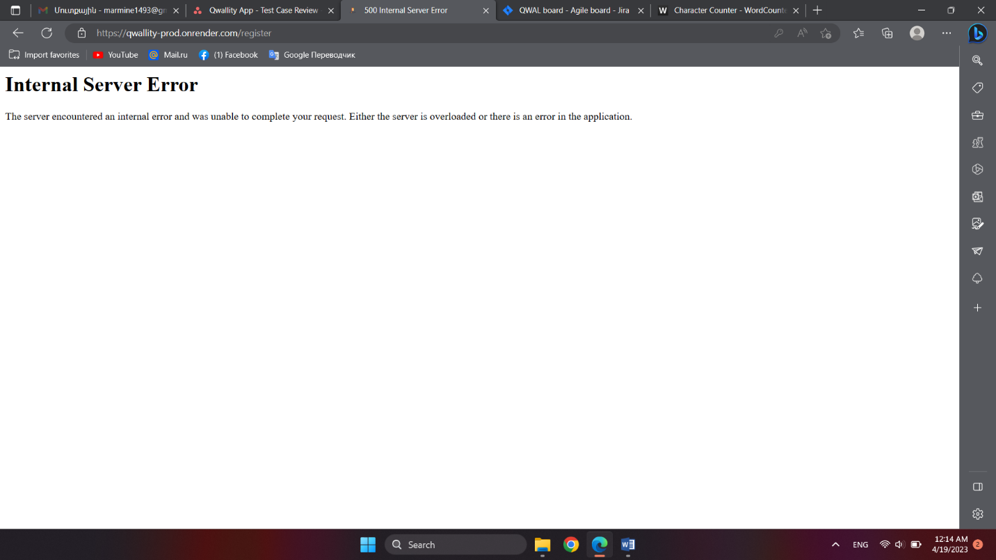

**Notes:** “Username“ field should be alphanumeric up to 50 characters

**Severity**: High

**Scenario 2**

**Acceptance Criteria**

Login screen contains the following fields: **Username, Password**

2 buttons: **Login, Cancel**

Link: **Forget your password**

**Toggle password visibility**

After successful login user redirects to Home page with following message “Welcome {registered name}”. After login with not existing user or not valid pass, system shows following message “Username or password is incorrect”.

Clicking on Toggle, you can see input password.

System should block account after user 6 attempts.

Cancel button should reset all entered data - both fields.

**Bug 4-There is not “Cancel” button on Login screen**

**Environment/URL:** [**QWALLITY Workspace (qwallity-prod.onrender.com)**](https://qwallity-prod.onrender.com/login)

**Operation System:** Windows 11 Home 64-bit

**Version**: 1

**Browser:** Microsoft Edge

**Submit Date:** 4/21/2023

**Reporter:** Armine Melkonyan

**Steps to Reproduce:**

1. Enter Qwallity App
2. Click “Login” Button

**Expected Result:** Login screen will be contains “Cancel“ Button

**Actual Result:** Login screen doesn’t contain “Cancel“ Button

**Screenshot/video:** Screenshot is attached

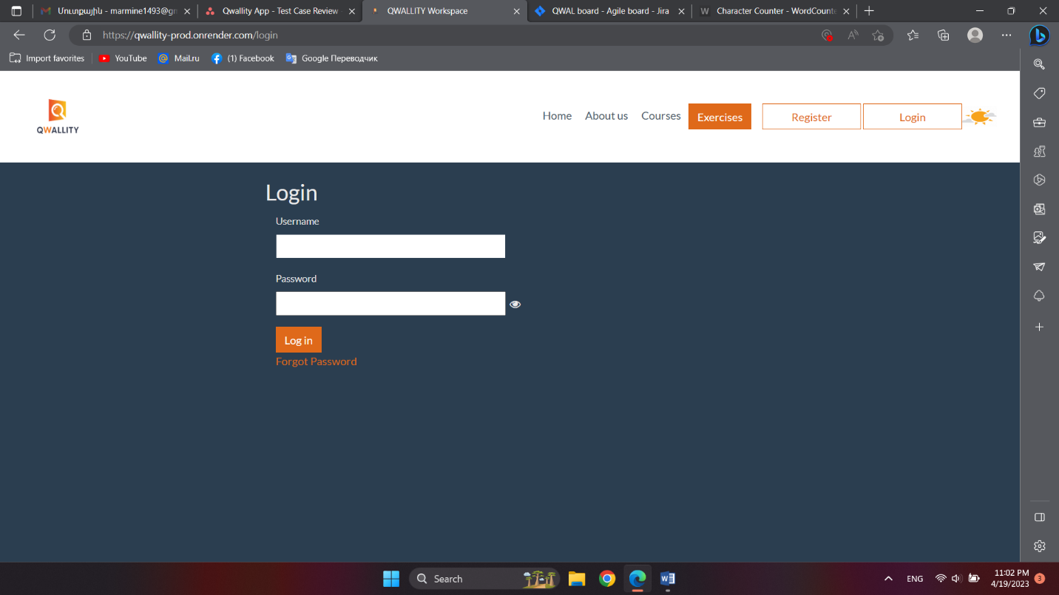

**Severity**: Low

**Bug 5-Wrong "Login" Button functionality**

**Environment/URL:** [**QWALLITY Workspace (qwallity-prod.onrender.com)**](https://qwallity-prod.onrender.com/login)

**Operation System:** Windows 11 Home 64-bit

**Version**: 1

**Browser:** Microsoft Edge

**Submit Date:** 4/21/2023

**Reporter:** Armine Melkonyan

**Steps to Reproduce:**

1. Enter Qwallity App
2. Enter Login page
3. Click “Log in“ Button

**Expected Result:** Should be shows validation message that “Please fill out fields“

**Actual Result:** When Username and Password fields are empty, user click on button “Log in” redirect to Home page.



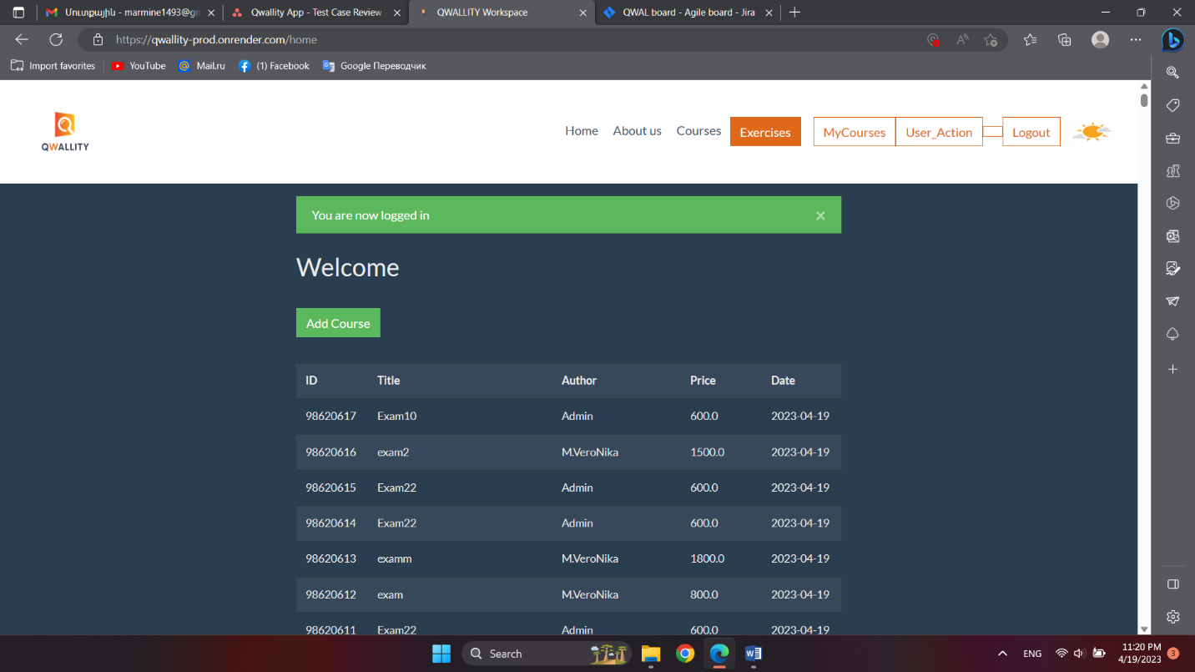 **Notes:** I think this is exactly considered an admin user, because there are features that only an admin can perform, from which other Bugs are derived during course increments․

**Severity**: Critical

**Bug 6-User lock error**

**Environment/URL:** [**QWALLITY Workspace (qwallity-prod.onrender.com)**](https://qwallity-prod.onrender.com/login)

**Operation System:** Windows 11 Home 64-bit

**Version**: 1

**Browser:** Microsoft Edge

**Submit Date:** 4/21/2023

**Reporter:** Armine Melkonyan

**Steps to Reproduce:**

1. Enter Qwallity App
2. Enter Login page
3. Enter valid Username
4. Enter invalid Password
5. Click “Log in“ Button
6. Repeat 3-5 steps 6 times

**Expected Result:** System should block account after 6 attempts

**Actual Result:** System don’t blocked account, user redirect to Home page

**Screenshot/video:** Screenshot is attached

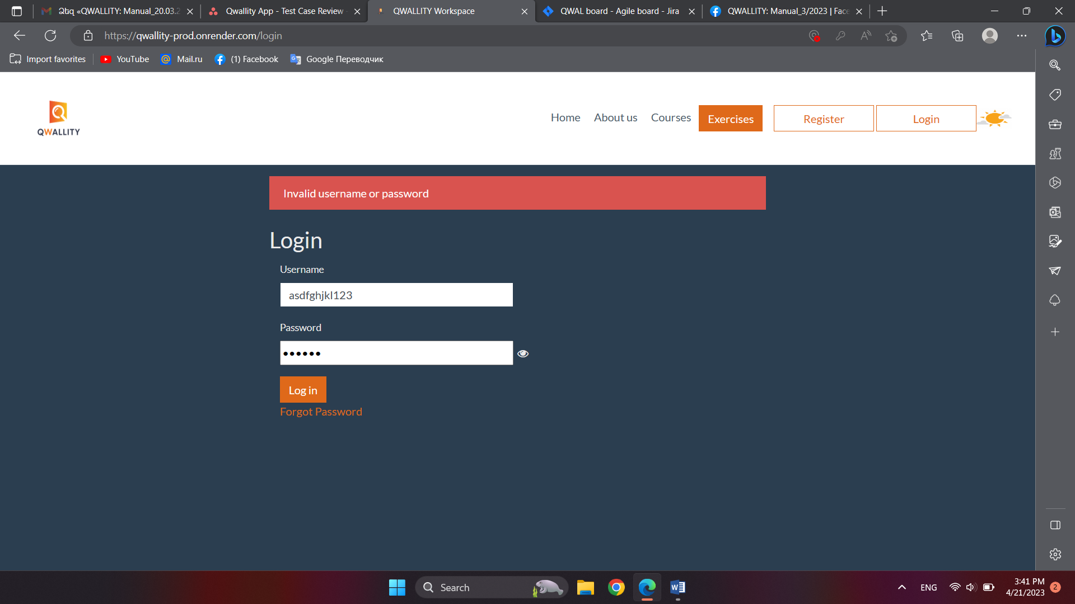

**Severiy**: High

**Scenario 1**

As a admin I want to be redirected to Home page after successful login...

**Acceptance Criteria**

Home screen contains the following information.

**"You are now logged in"** popup with "X" icon. User should be able to close this popup

**Welcome** <Username>

**Add Course** Green button. User should be able to add courses from home screen

**Table of existing courses** (Table columns-Id, Title, Price, Date) Courses are ordered by Date

For non admin user no ability for adding course.

**Bug 7-No ”Add Course” Button on the Home page as a Admin**

**Environment/URL:** [**QWALLITY Workspace (qwallity-prod.onrender.com)**](https://qwallity-prod.onrender.com/login)

**Operation System:** Windows 11 Home 64-bit

**Version**: 1

**Browser:** Microsoft Edge

**Submit Date:** 4/21/2023

**Reporter:** Armine Melkonyan

**Steps to Reproduce:**

1. Enter Qwallity App
2. Enter Login page
3. Enter Admin Usernam and Password
4. Click “Log in“ Button

**Expected Result:** System should be redirect to Home page where show “Add Course“ Button

**Actual Result:** There is no “Add Course“ Button

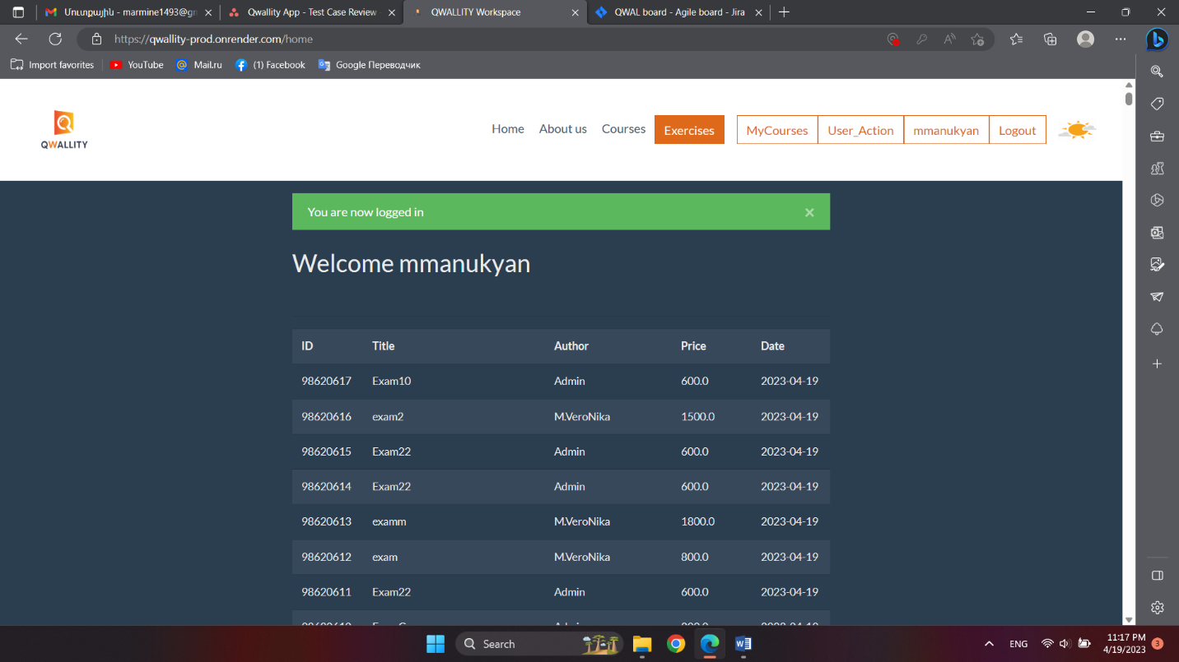**Screenshot/video:** Screenshot is attached

**Notes**: I think this is no Admin-user

**Severiy**: Critical

**Bug 8-On the screen Home page is unnecessary column**

**Environment/URL:** [**QWALLITY Workspace (qwallity-prod.onrender.com)**](https://qwallity-prod.onrender.com/login)

**Operation System:** Windows 11 Home 64-bit

**Version**: 1

**Browser:** Microsoft Edge

**Submit Date:** 4/21/2023

**Reporter:** Armine Melkonyan

**Steps to Reproduce:**

1. Enter Qwallity App
2. Enter Login page
3. Enter Admin Usernam and Password
4. Click “Log in“ Button

**Expected Result:** System should be redirect Home page. As per requirements table should have Id, Title, Price, Date columns

**Actual Result:** There is an unnecessary Author column

**Screenshot/video:** Screenshot is attached

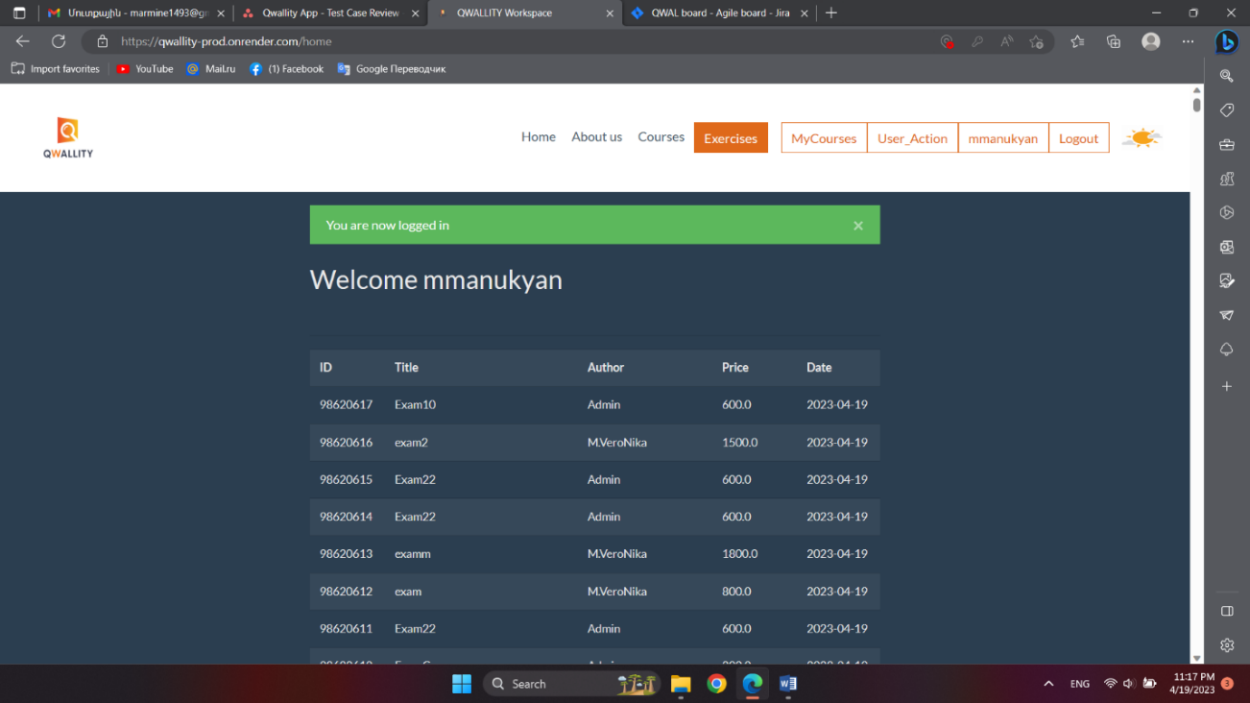

Severity: Low

**Bug 9-Courses օn Home page are not ordered right**

**Environment/URL:** [**QWALLITY Workspace (qwallity-prod.onrender.com)**](https://qwallity-prod.onrender.com/login)

**Operation System:** Windows 11 Home 64-bit

**Version**: 1

**Browser:** Microsoft Edge

**Submit Date:** 4/21/2023

**Reporter:** Armine Melkonyan

**Steps to Reproduce:**

1. Enter Qwallity App
2. Enter Login page
3. Enter Admin Usernam and Password
4. Click “Log in“ Button

**Expected Result:** On Home screen Courses well be ordered by date

**Actual Result:** Courses not ordered by date

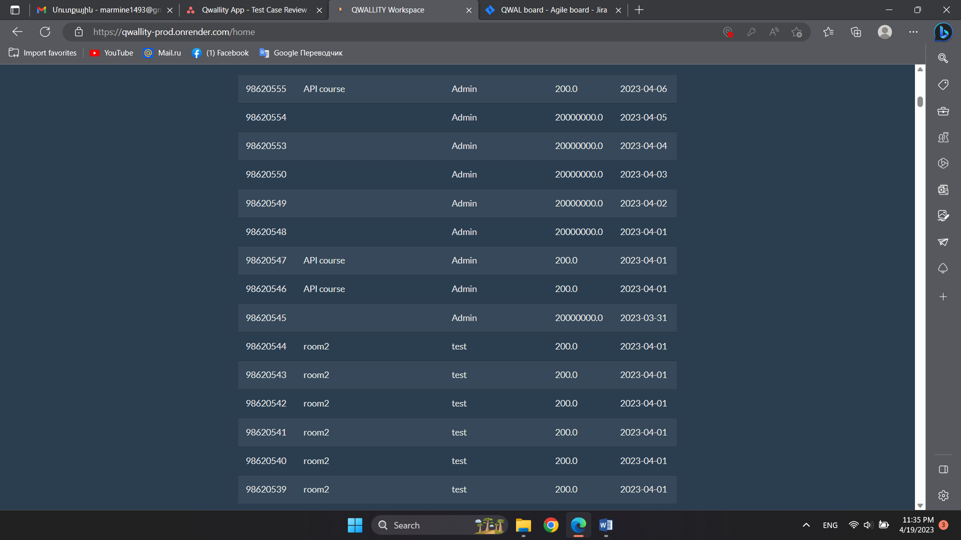**Screenshot/video:** Screenshot is attached

**Severity**: Low

**Scenario 4**

**As an admin** I want to be able add new course, edit or delete.

Both user groups - admin and non admin can view all courses.

**Acceptance Criteria**

1. **Add Course** screen should have 4 fields: **Title, Price, Type, Description** and **Submit** button(User can ad course from Home screen)

1. **Title -** System should allow alphabetical, up to 50 characters
2. **Price** - System should allow only numbers(int/float/decimal)
3. **Type -** Drop down should contain 2 types: Fundamental and Advanced
4. **Description** - Any characters, up to 250
5. **Submit button** - Should be in orange color.
6. After adding new course, user redirects to Home page, where all courses are visible.

2. User can see separated courses in Course page: **Advanced** and **Fundamental**

Selecting any of **Advanced** and **Fundamental,** user redirects to corresponding course section. **Author, Title** and **Buy** columns should be visible in screen. After clicking on Buy, user redirects to separate screen where can buy course. Screen contains the following fields:

**Course title-price, course description, Buy button(**orange color**)**

**Non Admin**

1. After clicking on **Buy** button
2. **Account Balance is insufficient**(in case of not enough account balance)
3. User redirects to **My Courses** screen (in case of enough account balance). User can see his/her bought courses

**Admin user**

1. Buy button is not visible
2. Title is link
3. After clicking on Title, admin redirects to Edit/delete screen
4. After clicking on Edit button, user redirects to Edit Course page. Page contains **Title** and **Description** fields, **Submit** button.
5. After submission, User get 'Your changes are done' message and redirects to Courses page.
6. After clicking on Delete button, admin redirects to Courses page, "**Course is deleted**" message displays.

**Bug 10-Wrong Title field on Add Course screen**

**Environment/URL:** [**QWALLITY Workspace (qwallity-prod.onrender.com)**](https://qwallity-prod.onrender.com/login)

**Operation System:** Windows 11 Home 64-bit

**Version**: 1

**Browser:** Microsoft Edge

**Submit Date:** 4/21/2023

**Reporter:** Armine Melkonyan

**Steps to Reproduce:**

1. Enter Qwallity App
2. Enter Login page
3. Click “Log in“ Button redirect to Home page
4. Click “Add Course“ Button
5. Title field write numbers
6. Click “Submit“ Button

**Expected Result:** Title field will be accept alphabetical up to 50 characters

**Actual Result:** Field accept numbers as well and no more than 10 characters

**Screenshot/video:** Screenshot is attached

**Severity**: Medium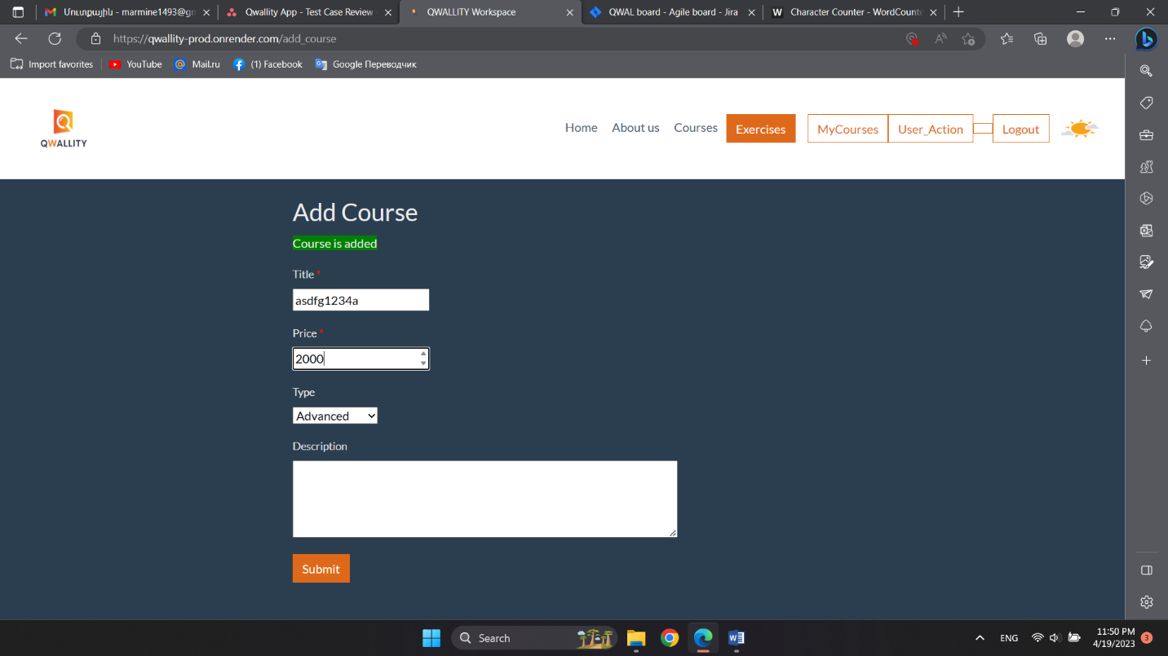

**Bug 11-Wrong Discription field on Add Course screen**

**Environment/URL:** [**QWALLITY Workspace (qwallity-prod.onrender.com)**](https://qwallity-prod.onrender.com/login)

**Operation System:** Windows 11 Home 64-bit

**Version**: 1

**Browser:** Microsoft Edge

**Submit Date:** 4/21/2023

**Reporter:** Armine Melkonyan

**Steps to Reproduce:**

1. Enter Qwallity App
2. Enter Login page
3. Click “Log in“ Button redirect to Home page
4. Click “Add Course“ Button
5. Description field write more then 250 character
6. Click “Submit“ Button

**Expected Result:** Field will be accept any characters, up to 250

**Actual Result:** Field accept more than 250 characters

**Screenshot/video:** Screenshot is attached

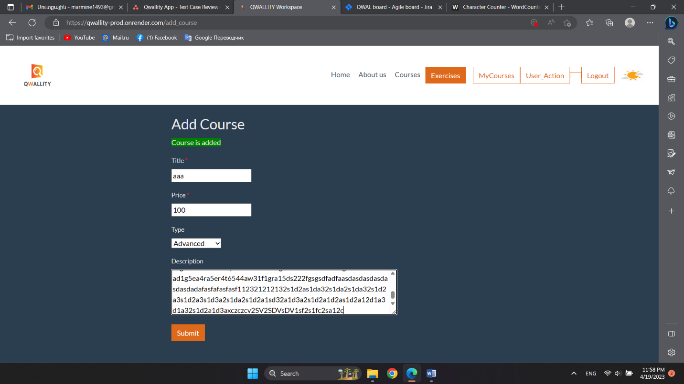

**Notes:** I entered App without Username and Password, because only there is “Add Course“ Button.

**Severity**: Medium

**Bug 12-Internal Server Error Login page "Forgot Password" link**

**Environment/URL:** [**QWALLITY Workspace (qwallity-prod.onrender.com)**](https://qwallity-prod.onrender.com/login)

**Operation System:** Windows 11 Home 64-bit

**Version**: 1

**Browser:** Microsoft Edge

**Submit Date:** 4/21/2023

**Reporter:** Armine Melkonyan

**Steps to Reproduce:**

1. Enter Qwallity App
2. Enter Login page
3. Fill in Username field
4. Press “Forgot Password“ link
5. Write correct email
6. Click “Send“ Button

**Expected Result:** A message should come to the email

**Actual Result:** Is bringing Internal Server Error

**Screenshot/video:** Screenshot is attached

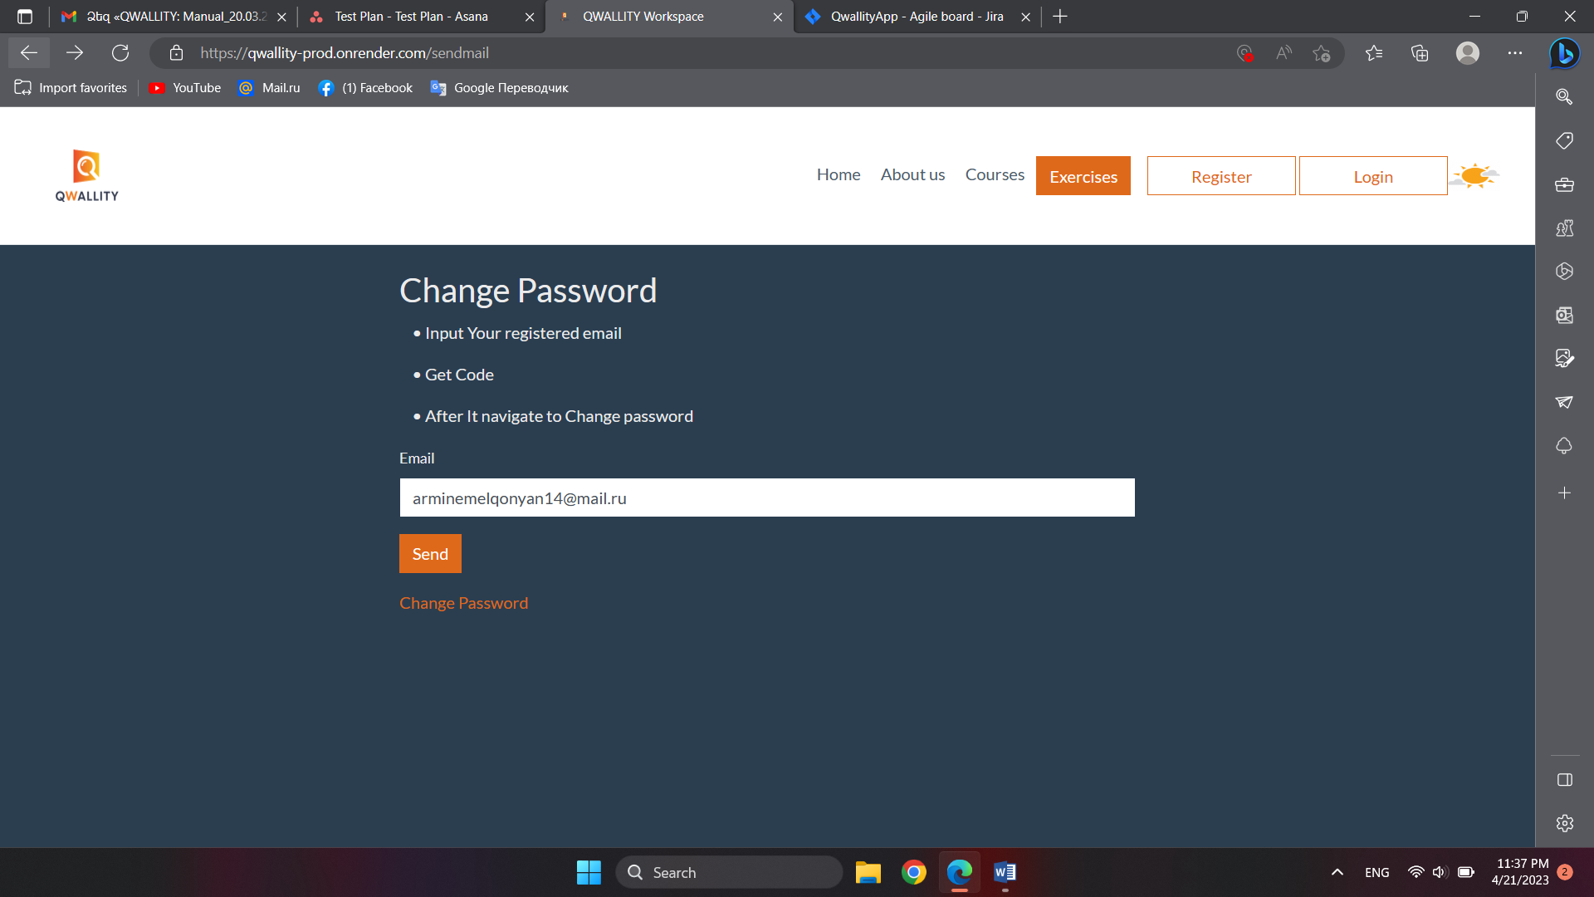

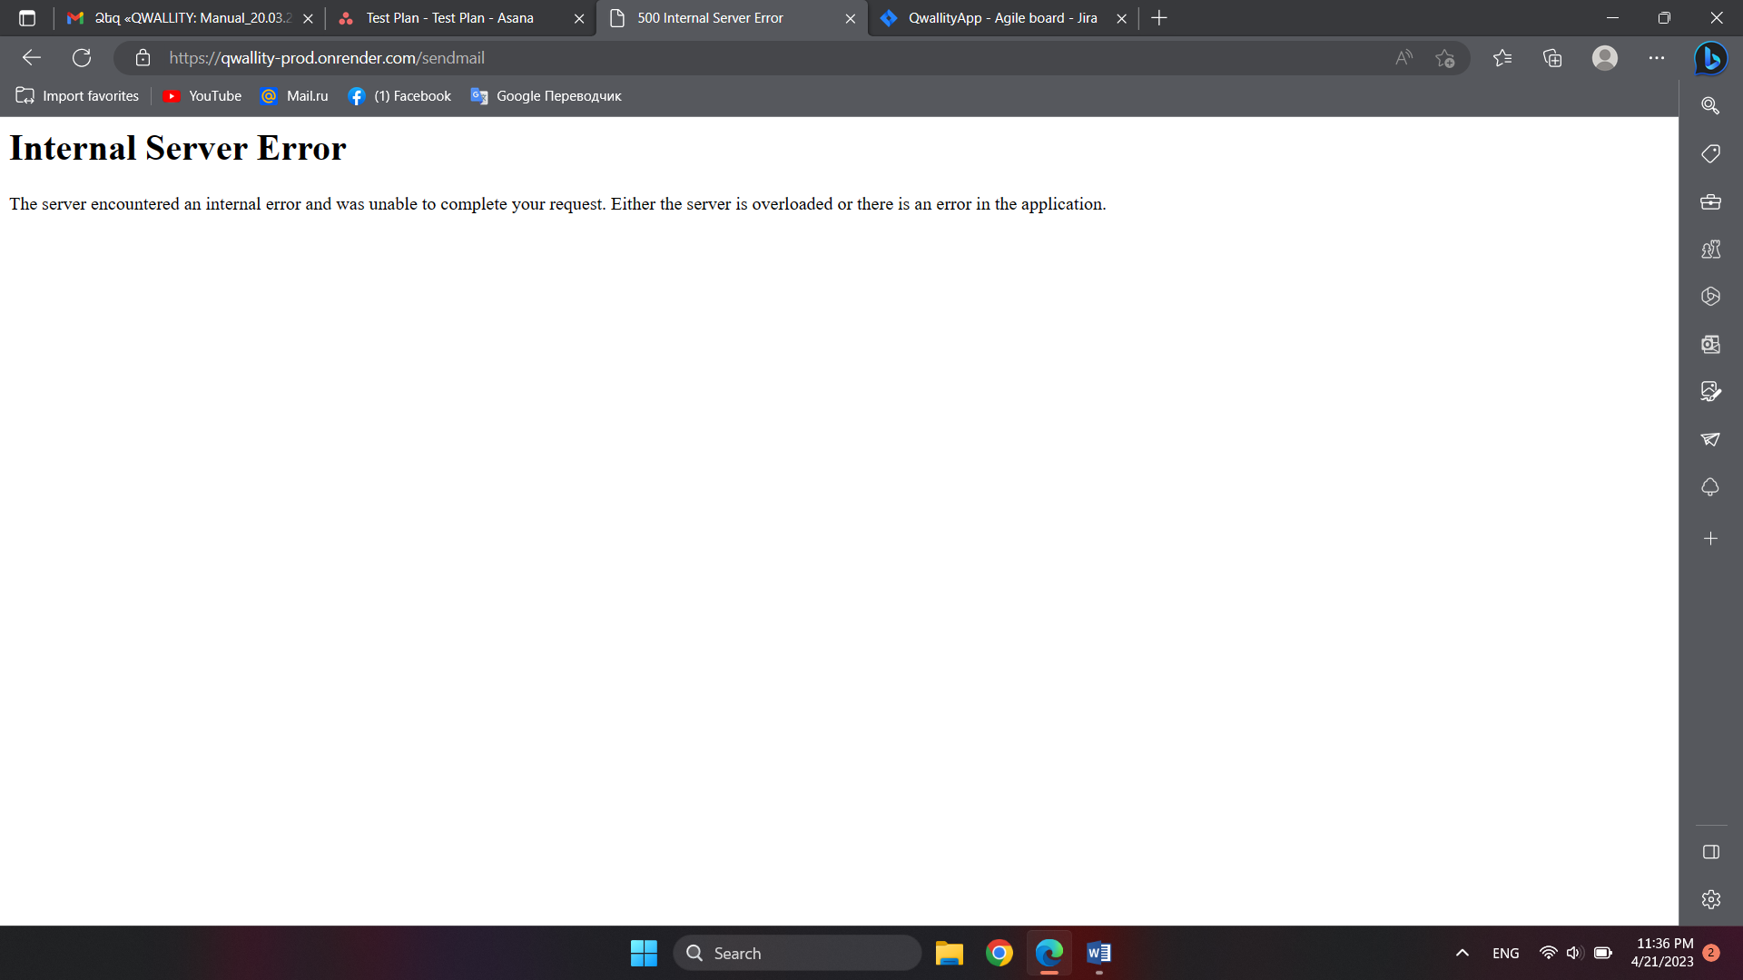

**Severity**: Critical